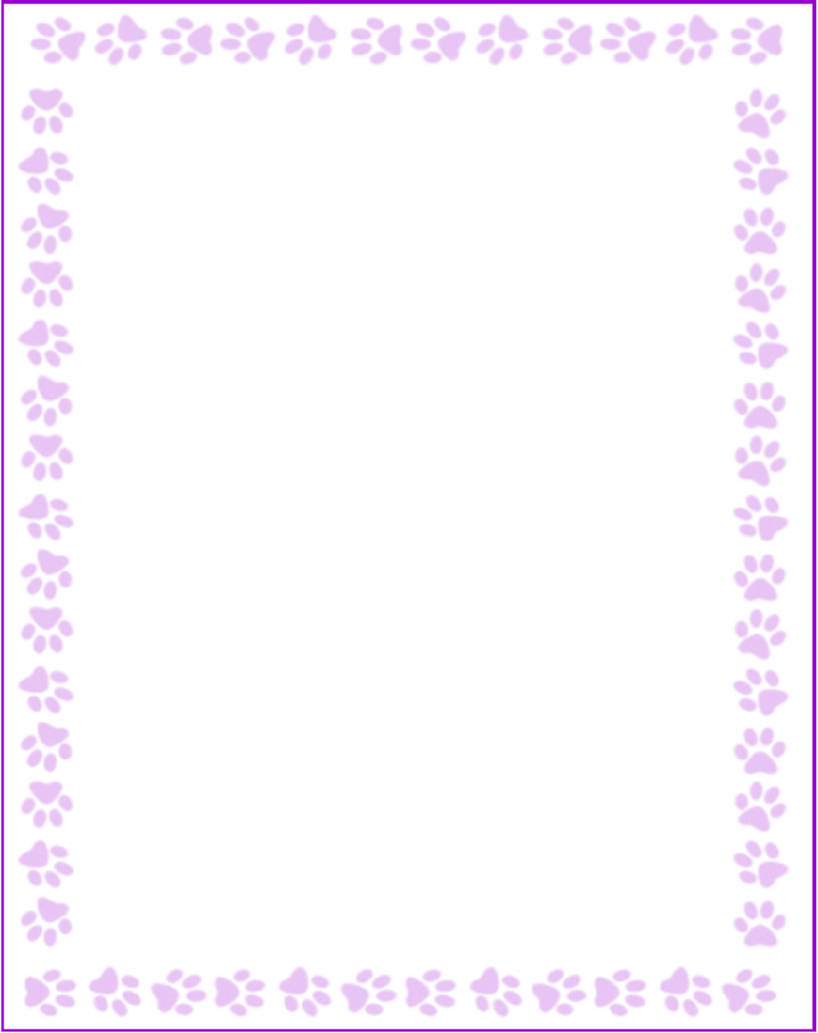

Teacher and Staff Favorites List

|  |  |
| --- | --- |
| Name: | School Psychologist |
| Grade or Position: | 02/21 |
| Birthday: | Dark Chocolate, Peanut Butter Cups |
| Favorite Candy: | Blue and Green |
| Favorite Color: | Orchids |
| Favorite Flowers: | Fun magnets and art work for decorating the classroom |
| Favorite Collectibles: | Anything vegetarian |
| Favorite Food: | Amazon, Target |
| Favorite Store: | Chai Tea Latte |
| Favorite Restaurant: | Marlow's, Cava |
| Interests and Hobbies: | Reading, Beach, Lake |
| Things I have too many of: |  |
| Things I am allergic to: | I'm a baseball mom. Fan of the Braves and Ga Tech! |
| Other comments: | Vegetarian |