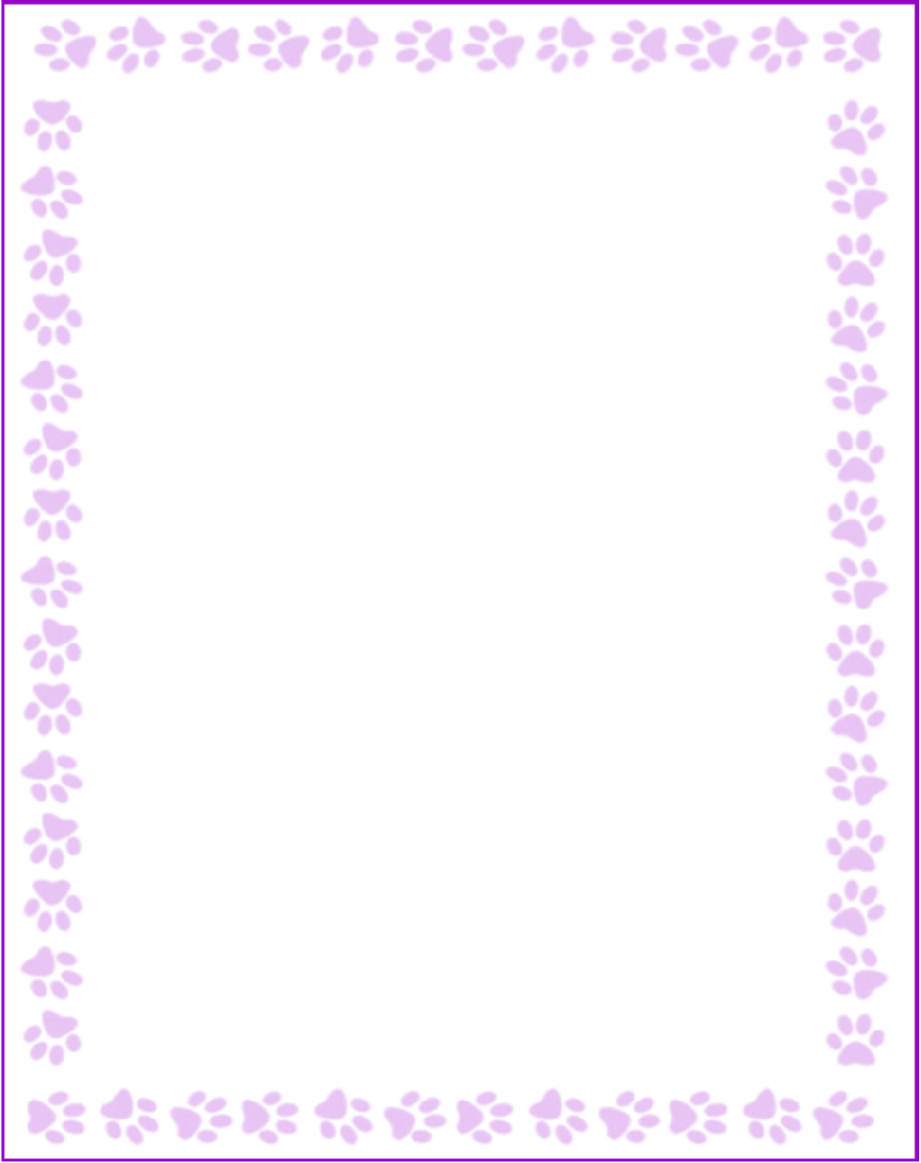

Teacher and Staff Favorites List

|  |  |
| --- | --- |
| Name: | Belinda M Nebie |
| Grade or Position: | Registrar/Transportation |
| Birthday: | 05/11 |
| Favorite Candy: | Starburst |
| Favorite Color: | Earth Colors |
| Favorite Flowers: | Lily |
| Favorite Collectibles: | Refrigerator magnets |
| Favorite Food: | Sushi |
| Favorite Store: | Sephora, GAP |
| Favorite Restaurant: | Flat White from Starbucks |
| Interests and Hobbies: | Marlow's Tavern and Taqueria Tsunami |
| Things I have too many of: | Researching Ancient Civilization |
| Things I am allergic to: | Nothing |
| Other comments: | I love to travel! and I love House Music! |