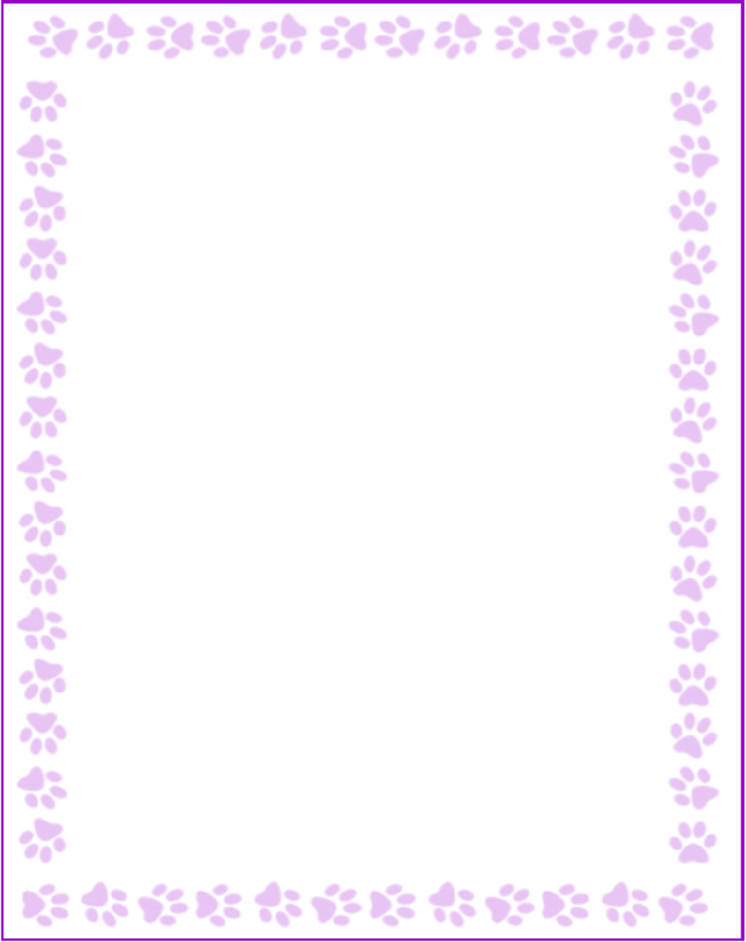

Teacher and Staff Favorites List

|  |  |
| --- | --- |
| Name: | 4th gen ed |
| Grade or Position: | 3/06 |
| Birthday: | rolos |
| Favorite Candy: | yellow |
| Favorite Color: | sunflowers |
| Favorite Flowers: | legos |
| Favorite Collectibles: | french fries |
| Favorite Food: | amazon |
| Favorite Store: | sweet tea |
| Favorite Restaurant: | Duluth Diner |
| Interests and Hobbies: | painting, legos, golf |
| Things I have too many of: |  |
| Things I am allergic to: |  |
| Other comments: |  |