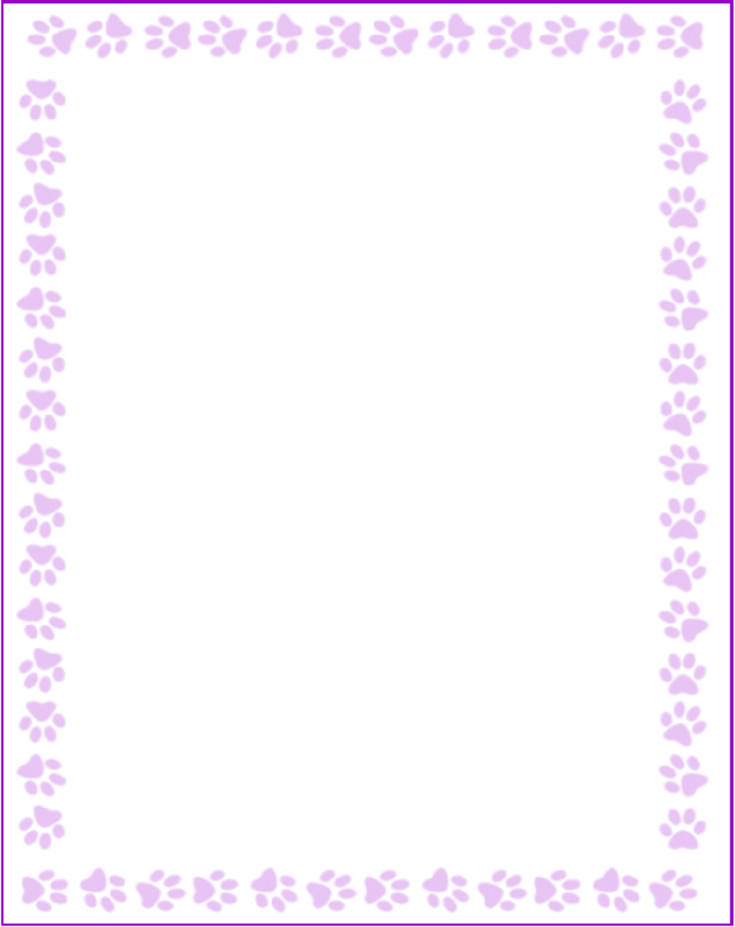

Teacher and Staff Favorites List

|  |  |
| --- | --- |
| Name: | Parul Chudasama |
| Grade or Position: | 3rd and 4th Grade |
| Birthday: | September 21 |
| Favorite Candy: | Lindt Truffles |
| Favorite Color: | Peacock Blue |
| Favorite Flowers: | Rose |
| Favorite Collectibles: |  |
| Favorite Food: | Indian Food (Dosa & Curry) |
| Favorite Store: | Belk |
| Favorite Restaurant: | Starbucks, Thai restaurant |
| Interests and Hobbies: | Crochet & Knitting |
| Things I have too many of: | Scarfs |
| Things I am allergic to: |  |
| Other comments: | I like to do Cooking |